**High Frequency Distortion** is caused by **parallel capacitance** and results in an increase in the **Rise & Fall Times** of a square wave.

* 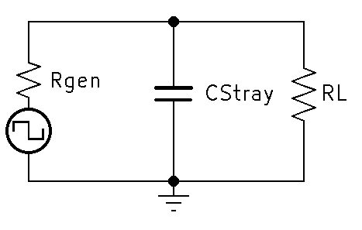Consider the following circuit

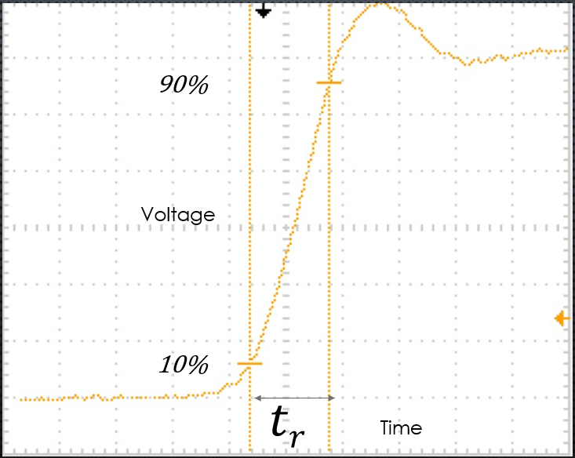

* Using Square-Wave analysis and a known rise time, we can calculate the circuits high critical frequency by dividing .35/(rise time).

$f_{CH}= \frac{0.35}{tr}$

$tr= \frac{0.35}{f_{CH}}$

**Deriving the High Critical Frequency Formula:**

**Givens:**

* *Rise Time is measured from 10% to 90%*

$Rise Time=tr$

$Frequency Cutoff High=fch$

$fch= \frac{0.35}{tr}$

**Known Formulas from Second Semester:**

* Xc =

**Knowing that at Critical Frequency Xc is equal to R, we can derive the following**

* Xc = $\frac{1}{2πFC}$
* @ FCH, R = XC
* R = $\frac{1}{2πFC}$
* FCH =

**Rise time is the time measured from 10% to 90% of the waveform amplitude. Therefore, If you set the equation in terms of rise time we get the following**

$Vc=vfin -\left(vfin -vin\right)e^{\frac{-t}{RC}}$

$Vc=.9vfin$

* $vin$ = .1 $vfin$

$t=tr$

**And Therefore,**

$.9vfin=vfin -\left(vfin -\text{.1} vfin \right)e^{\frac{-tr}{RC}}$

$.9vfin=vfin -\left(vfin -\text{.}\text{1 }vfin \right)e^{\frac{-tr}{RC}}$

$.9vfin-vfin= (-vfin+\text{.}\text{1 }vfin)e^{\frac{-tr}{RC}}$

$-.1vfin=\text{(}\text{-.}\text{9 }vfin)e^{\frac{-tr}{RC}}$

* $\frac{-.1vfin}{-.9vfin}$ = $e^{\frac{-tr}{RC}}$
* $\frac{1}{9}$ = $e^{\frac{-tr}{RC}}$
* $\ln{\frac{1}{9}}$ = $\frac{-tr}{RC}$
* -2.19722 = $\frac{-tr}{RC}$
* $RC$ = $\frac{tr}{2.19722}$

**We have solved for two formulas, now we can solve the final equation.**

* + = & *FCH* =
  + *FCH* =
  + *FCH* =
  + ***FCH* =** OR ***FCH* =**

**References**:

Bell, D. A. (1997). *Solid state pulse circuits*. Sarnia, ON: David A. Bell.